**Hello World RESTful Web Service**

Write a REST service in the spring learn application created earlier, that returns the text "Hello World!!" using Spring Web Framework.

**Code:**

**application.properties**

spring.application.name=spring-learn

server.port=8081

**HelloController.java**

package com.cognizant.spring_learn.controller;

import org.slf4j.Logger;

import org.slf4j.LoggerFactory;

import org.springframework.web.bind.annotation.GetMapping;

import org.springframework.web.bind.annotation.RestController;

@RestController

public class HelloController {

private static final Logger LOGGER = LoggerFactory.getLogger(HelloController.class);

@GetMapping("/hello")

public String sayHello() {

LOGGER.info("START - sayHello()");

String message = "Hello World!!";

LOGGER.info("END - sayHello()");

return message;

}

}

**REST - Country Web Service**   
  
Write a REST service that returns India country details in the earlier created spring learn application.

**Country.java**

package com.cognizant.spring_learn.model;

public class Country {

private String name;

private String code;

// Getters and Setters

public String getName() { return name; }

public void setName(String name) { this.name = name; }

public String getCode() { return code; }

public void setCode(String code) { this.code = code; }

}

**CountryController.java**

package com.cognizant.spring_learn.controller;

import com.cognizant.spring_learn.model.Country;

import org.springframework.web.bind.annotation.GetMapping;

import org.springframework.web.bind.annotation.RestController;

@RestController

public class CountryController {

@GetMapping("/country")

public Country getCountry() {

Country country = new Country();

country.setName("India");

country.setCode("IN");

return country;

}

}

**OUTPUT:**

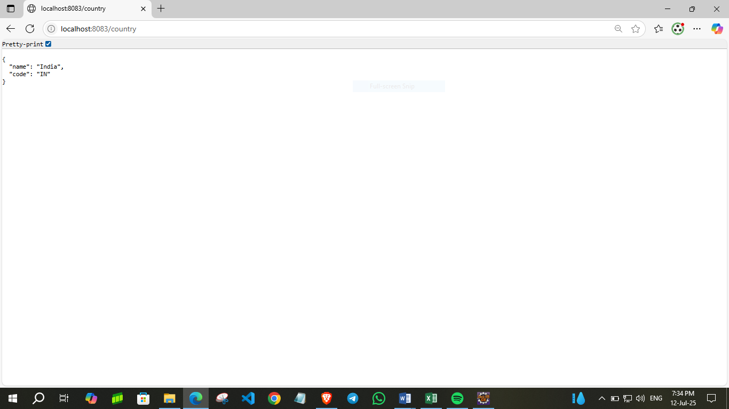

**REST - Get country based on country code** 

CODE:

**Country.xml**

<?xml version="1.0" encoding="UTF-8"?>

<beans xmlns="http://www.springframework.org/schema/beans"

xmlns:xsi="http://www.w3.org/2001/XMLSchema-instance"

xsi:schemaLocation="http://www.springframework.org/schema/beans

https://www.springframework.org/schema/beans/spring-beans.xsd">

<bean id="in" class="com.cognizant.spring_learn.model.Country">

<property name="code" value="IN"/>

<property name="name" value="India"/>

</bean>

</beans>

**CountryList.java**

package com.cognizant.spring_learn.model;

import java.util.List;

import jakarta.xml.bind.annotation.XmlElement;

import jakarta.xml.bind.annotation.XmlRootElement;

@XmlRootElement(name = "countries")

public class CountryList {

private List<Country> countries;

@XmlElement(name = "country")

public List<Country> getCountries() { return countries; }

public void setCountries(List<Country> countries) { this.countries = countries; }

}

**CountryService.java**

package com.cognizant.spring_learn.service;

import com.cognizant.spring_learn.model.Country;

import com.cognizant.spring_learn.model.CountryList;

import org.springframework.stereotype.Service;

import jakarta.xml.bind.JAXBContext;

import jakarta.xml.bind.Unmarshaller;

import java.io.InputStream;

@Service

public class CountryService {

public Country getCountry(String code) throws Exception {

InputStream is = getClass().getResourceAsStream("/country.xml");

if (is == null) {

throw new Exception("country.xml not found in resources");

}

JAXBContext context = JAXBContext.newInstance(CountryList.class);

Unmarshaller unmarshaller = context.createUnmarshaller();

CountryList countryList = (CountryList) unmarshaller.unmarshal(is);

return countryList.getCountries().stream()

.filter(c -> c.getCode().equalsIgnoreCase(code))

.findFirst()

.orElseThrow(() -> new Exception("Country with code " + code + " not found"));

}

}

**OUTPUT:**

